Propose Screen
Customer Interface Module

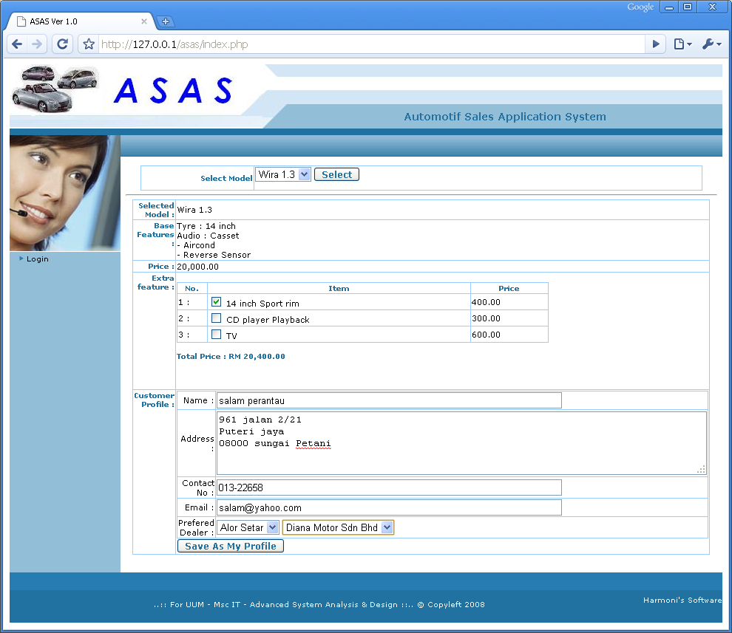
Screen id : 01 - Customer Interface

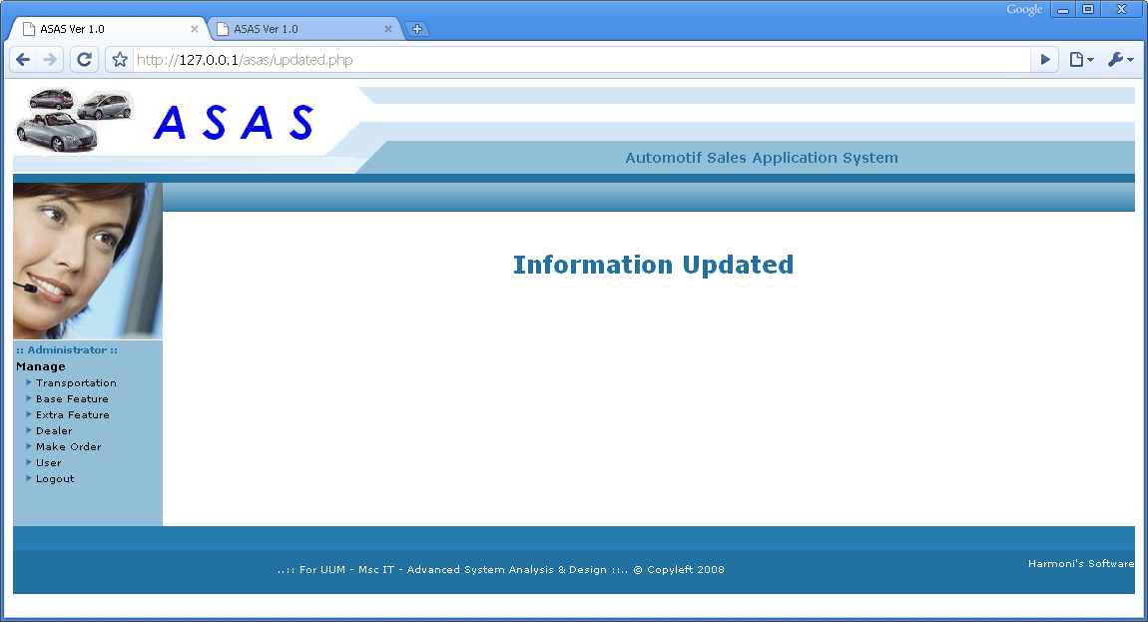
Screen id : 02 - If customer hit “Save As My Profile”

Login Module

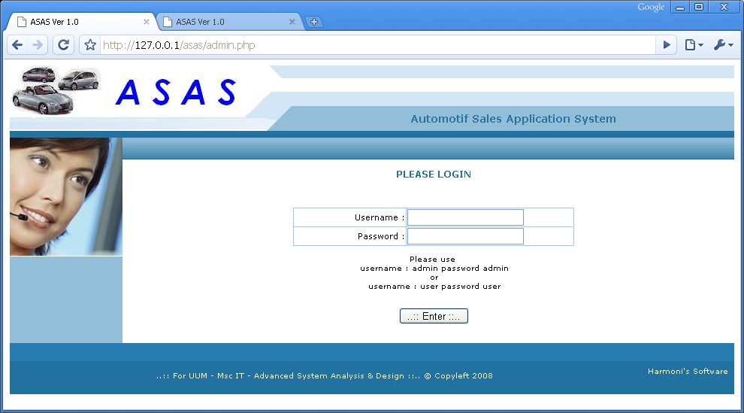
Screen id : 03 - Login screen for Manufacturing Administrator

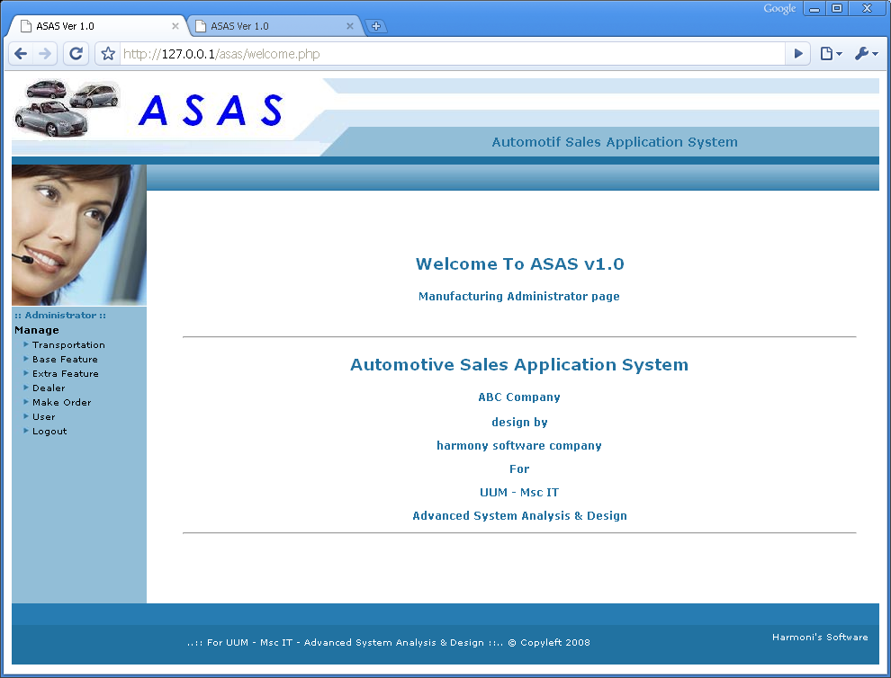
Screen id : 04 - Administrative Screen
Manage Transport Module

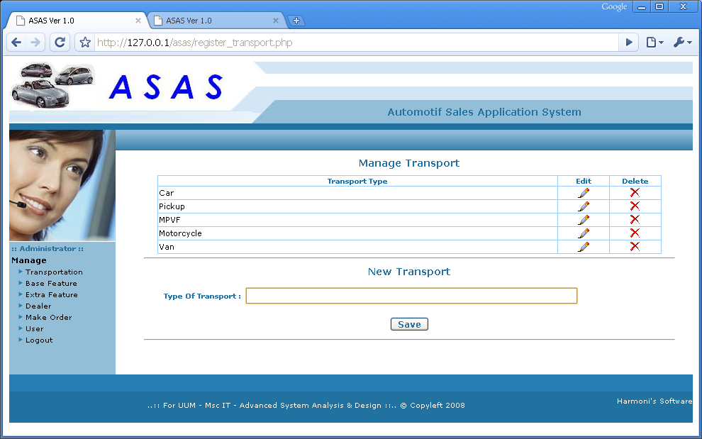
Screen id : 05 - Manage Type Of Transportation

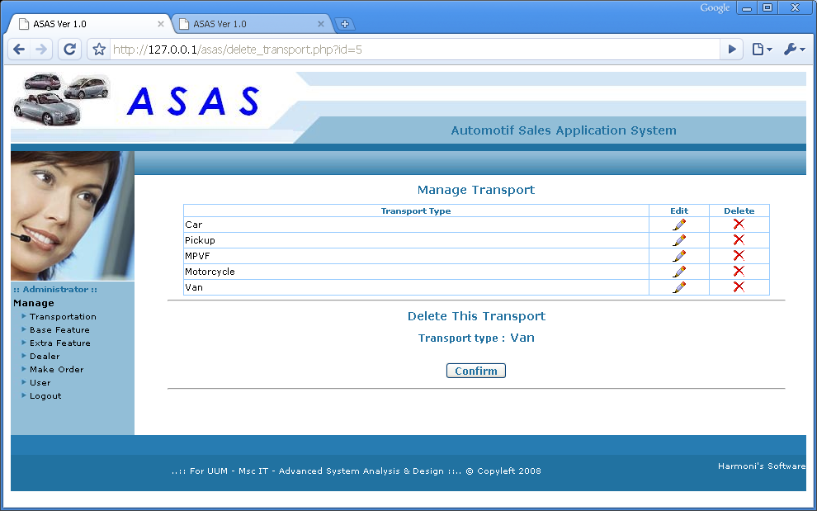
Screen id : 06 - Delete Transportation

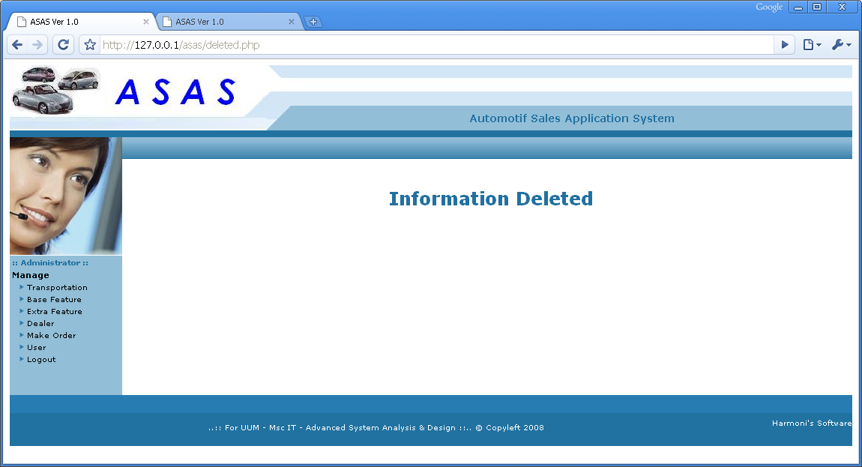
Screen id : 07 - Transportation Deleted

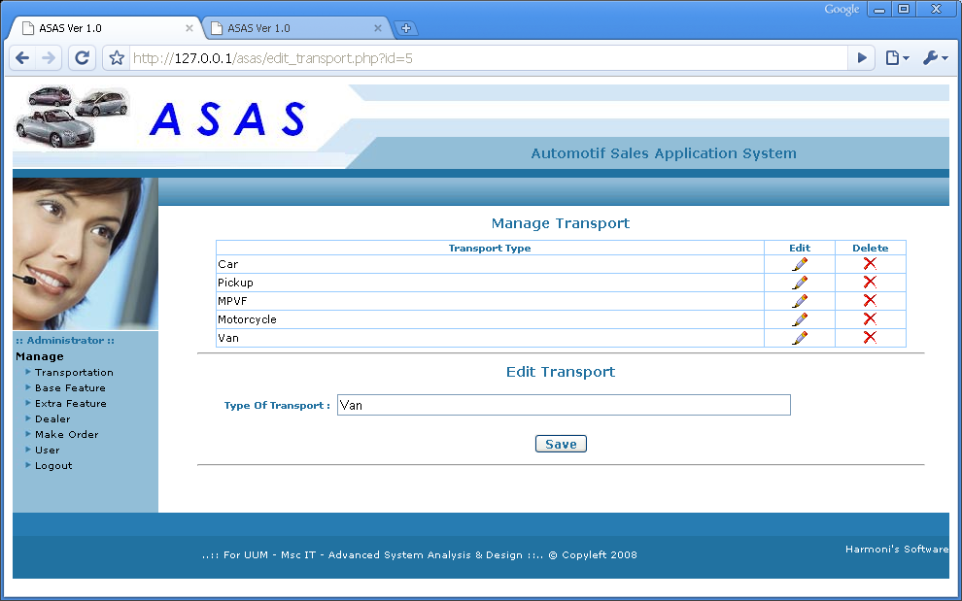
Screen id : 08 - Edit Transportation

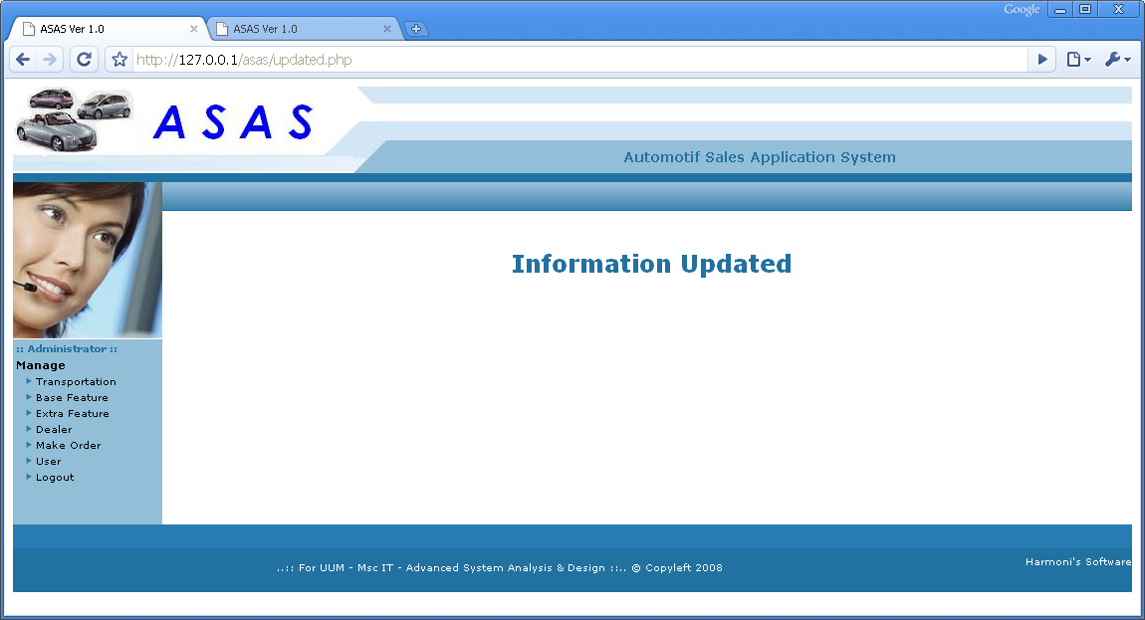

Screen id : 09 - Transportation Updated

Manage Base Feature Module

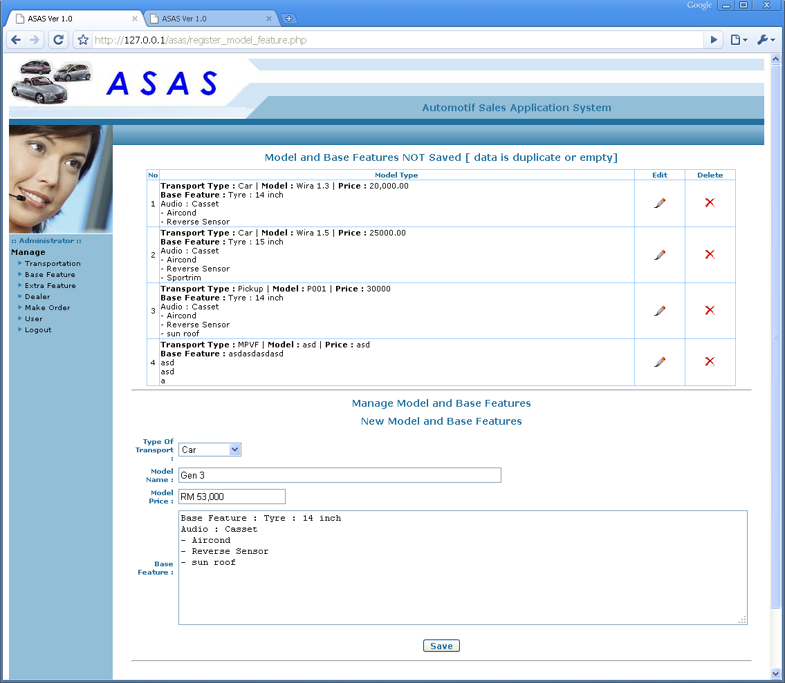
Screen id : 10 - New base feature

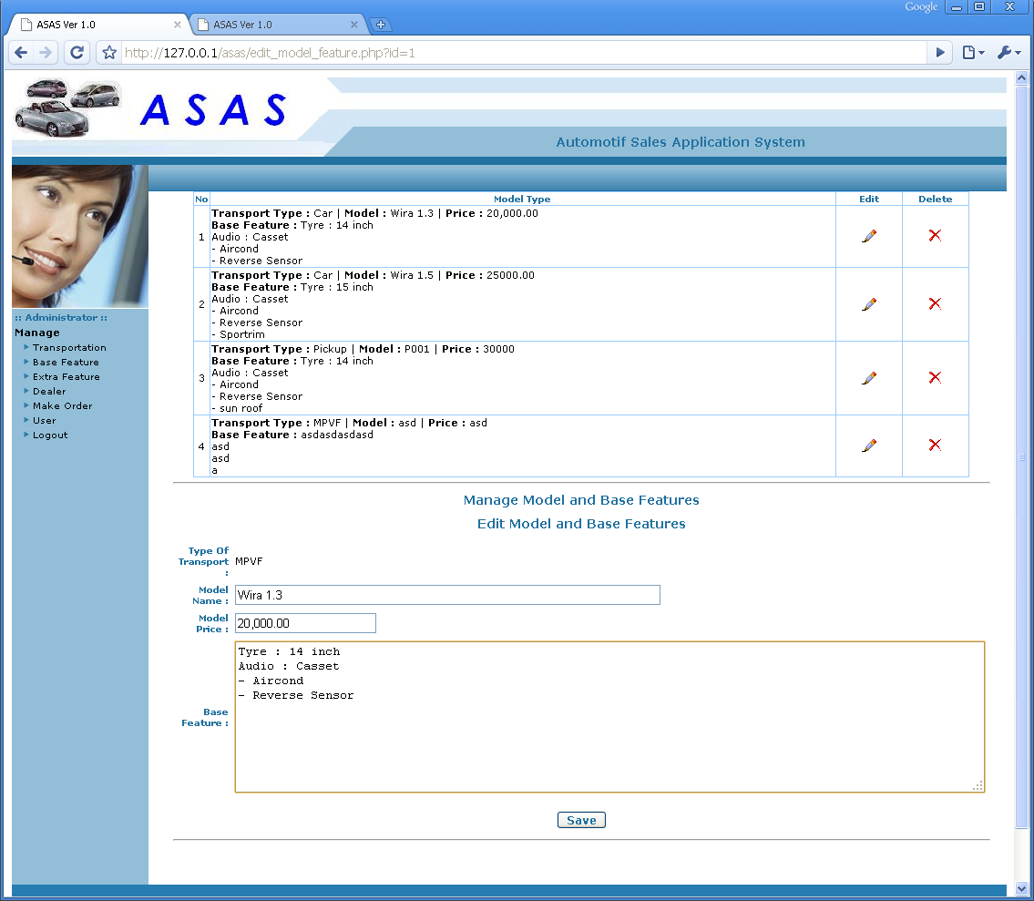
Screen id : 11 - Edit Model and Base feature

Screen id : 12 - Save Information

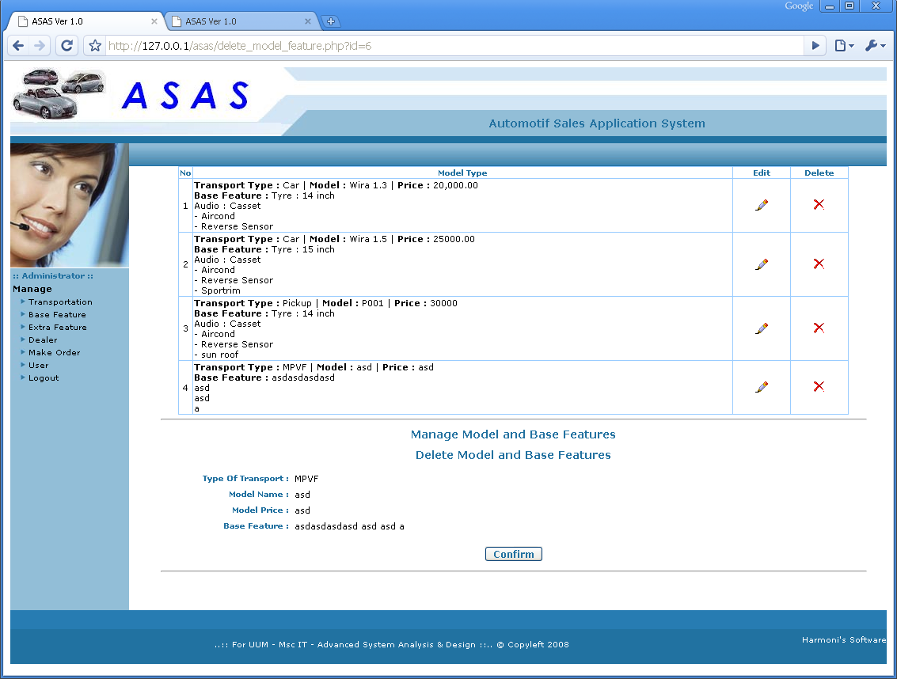

Screen id : 03 - Delete base feature

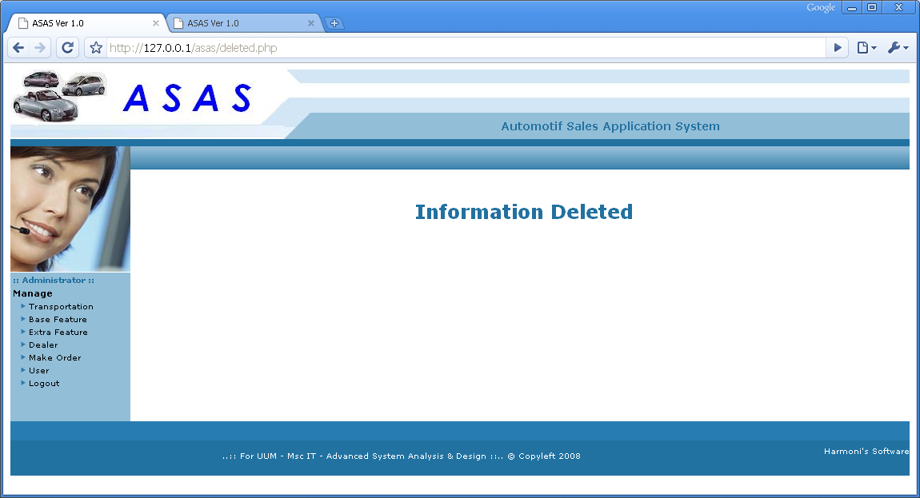

Screen id : 14 - Base Feature Deleted
Manage Extra Feature Module

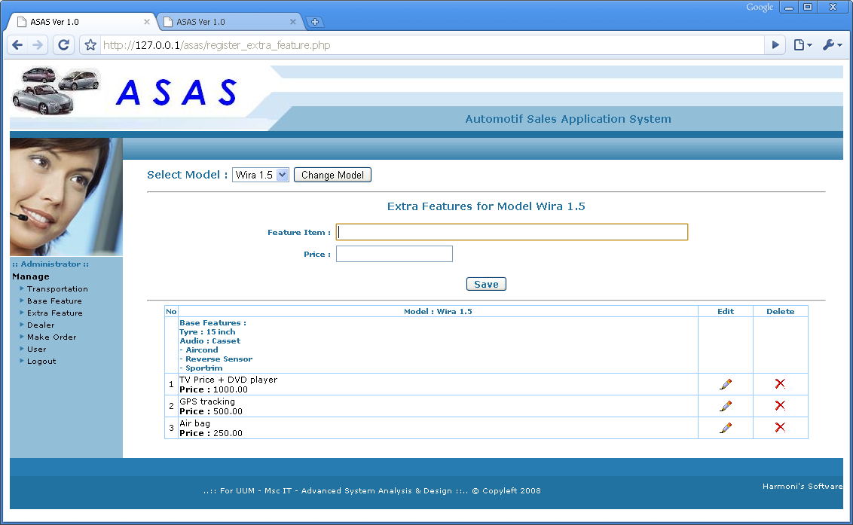
Screen id : 15 - Enter Extra Feature

Manage Dealer Information Module
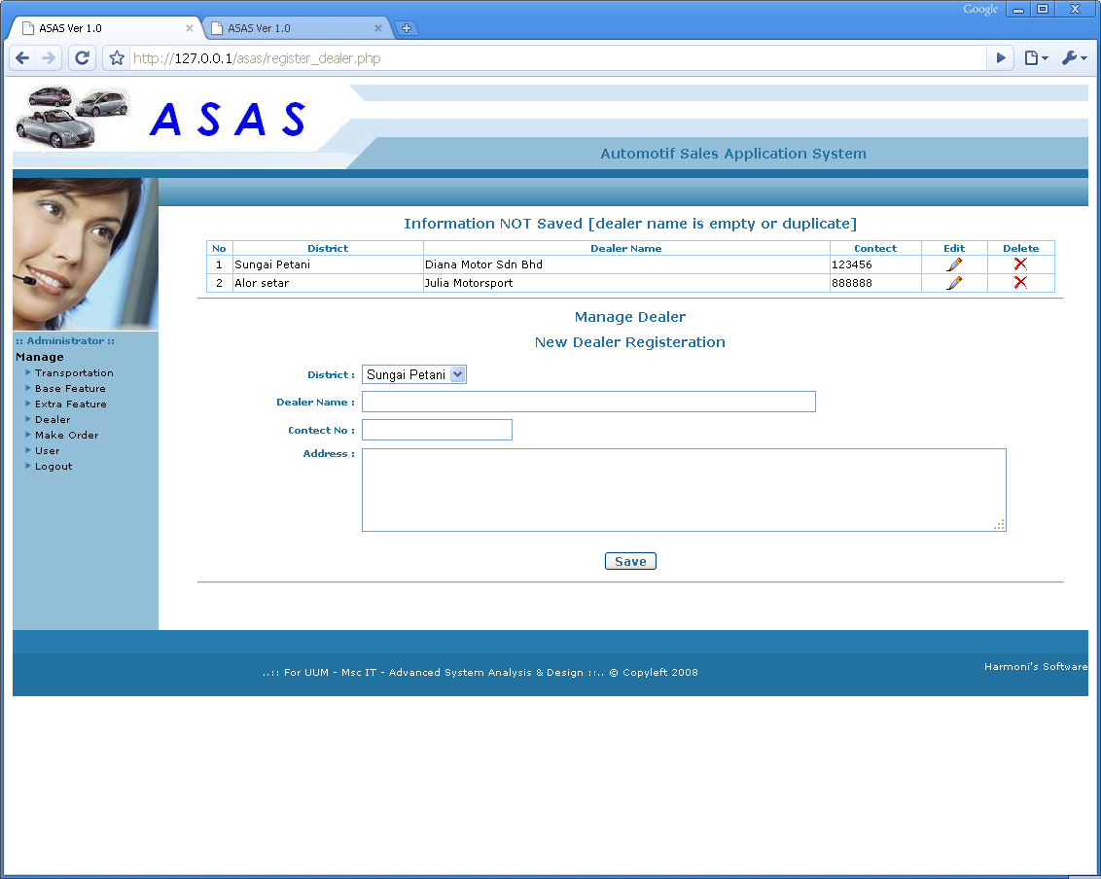.
Screen id : 16 - Dealer Information

Manage User Module 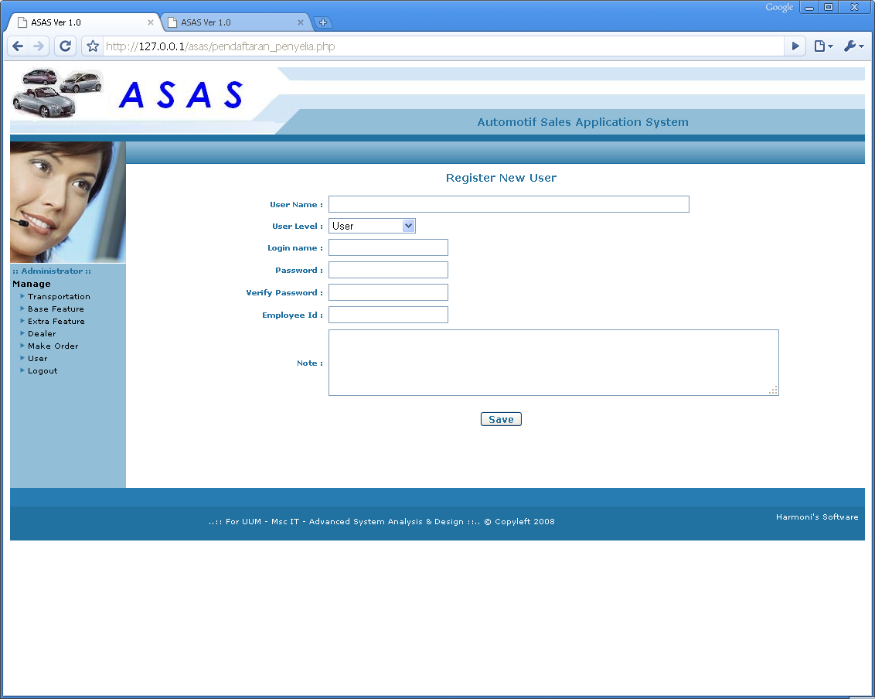

Screen id : 17 - Register new user

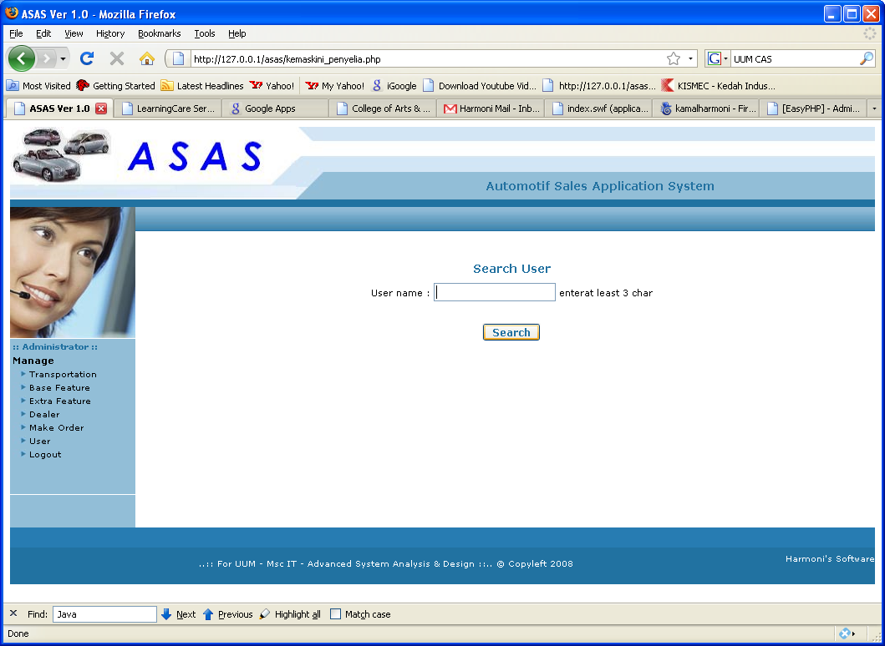
Screen id : 18 - Edit user

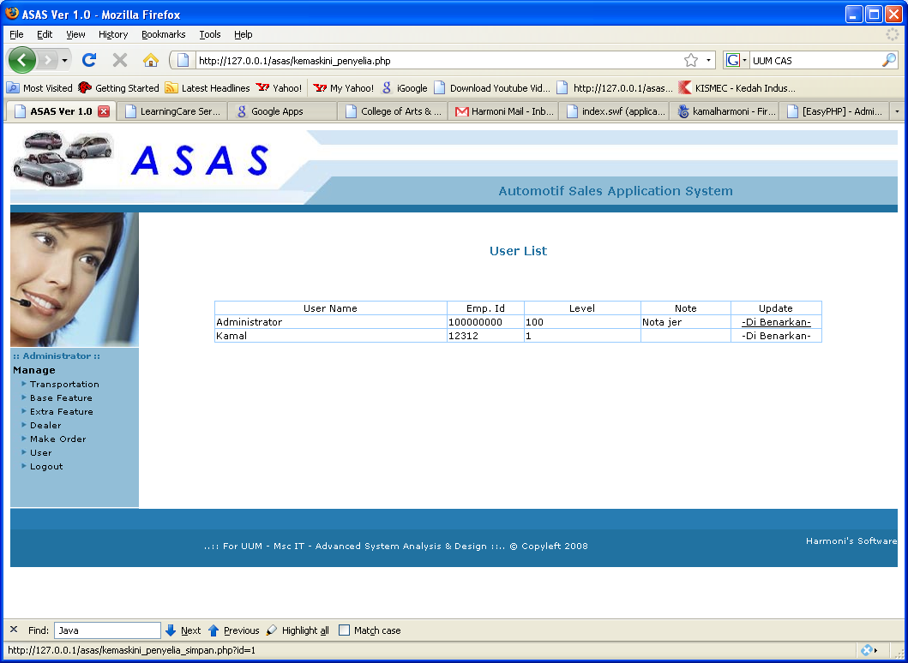
Screen id : 19 - User list to edit

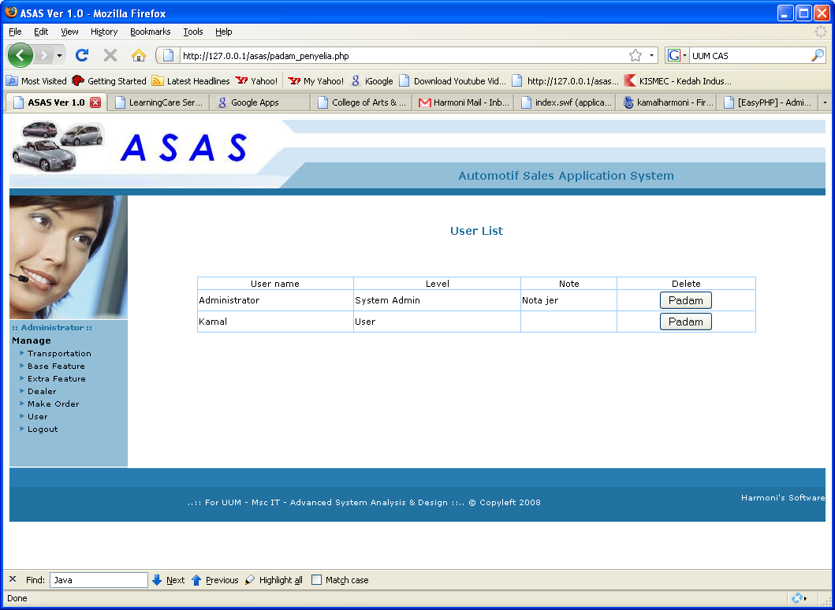
Screen id : 20 - Delete user

