WIRELESS HACK USING CAIN

Wireless
router
internet

- Open CAIN.

CAIN

- - Click button “Sniffer” at “Sniffer toolbar”. Next, Click “Add to list” button.
-“MAC Address Scanner” table will pop-up. Fill the range of ip address that you wanted to sniff.
Add to list
Start/stop sniffer
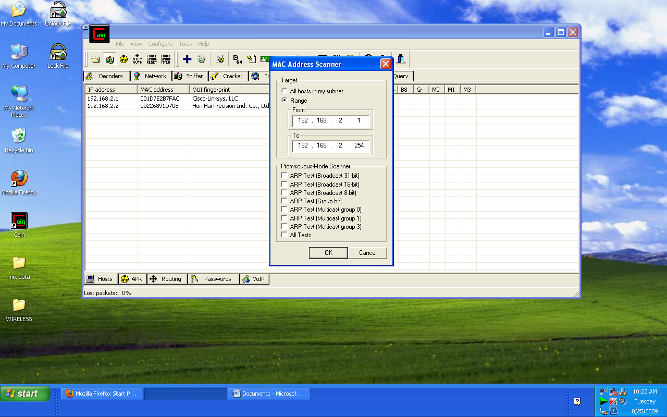
Sniffer toolbar
- Click at APR toolbar.
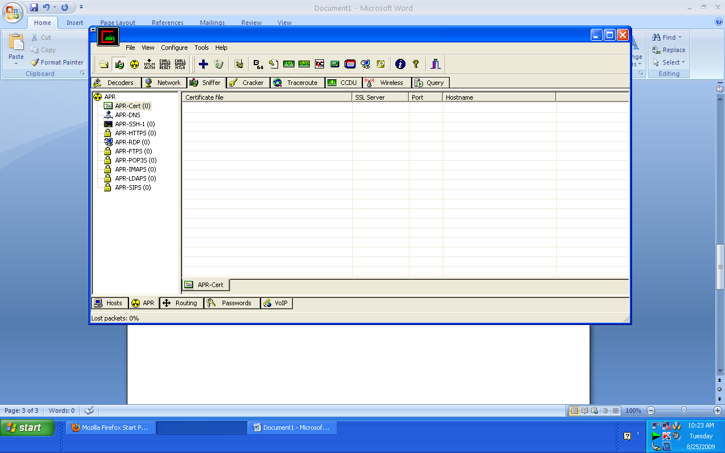
APR toolbar

- - Push the “Add to list” button again and “New ARP Poison Routing” will pop-up.
- An ip address will appear in the left table. Choose which ip you would like to sniff.
- In this case, I’ve choose 192.168.2.1 because it was a gateway. Then all the ip address in gateway 192.168.2.1 will appear in the right table.
Add to list
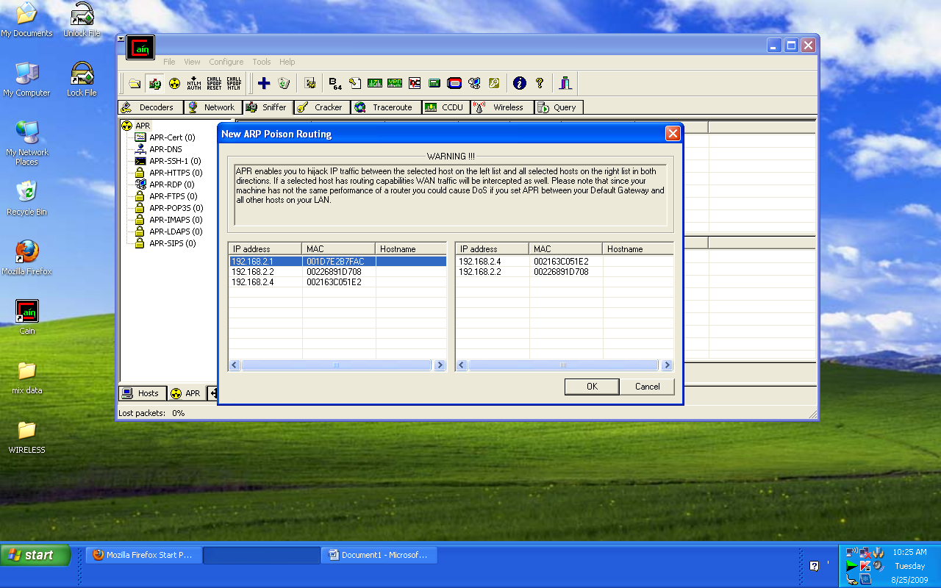
- Select the ip address that you wanted to sniff.
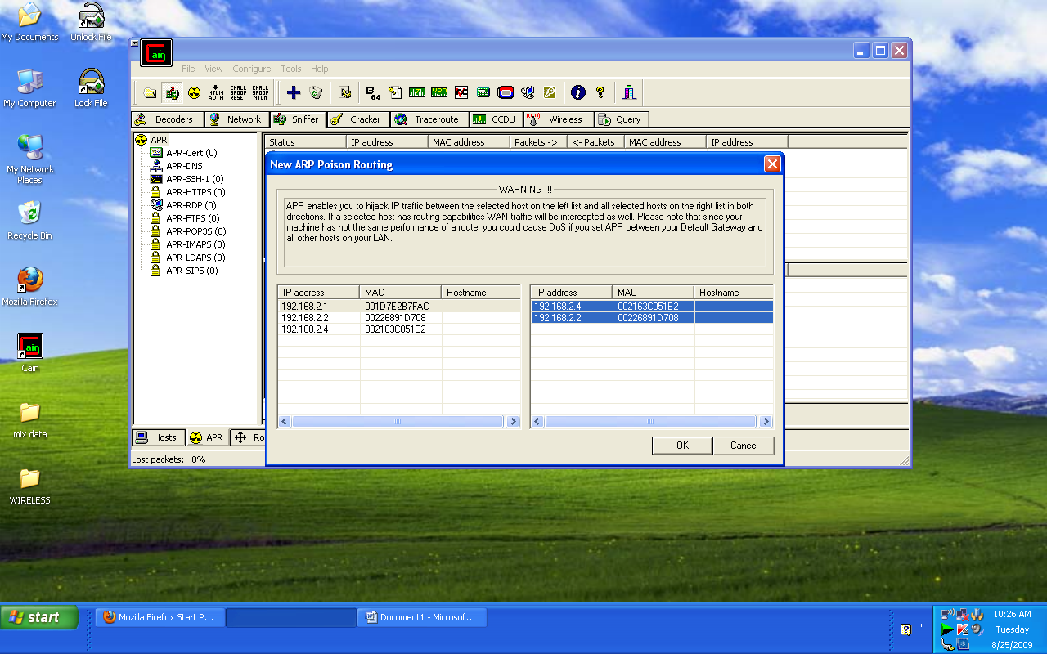

- In the table below it will appear the status for the ip address you’ve selected.
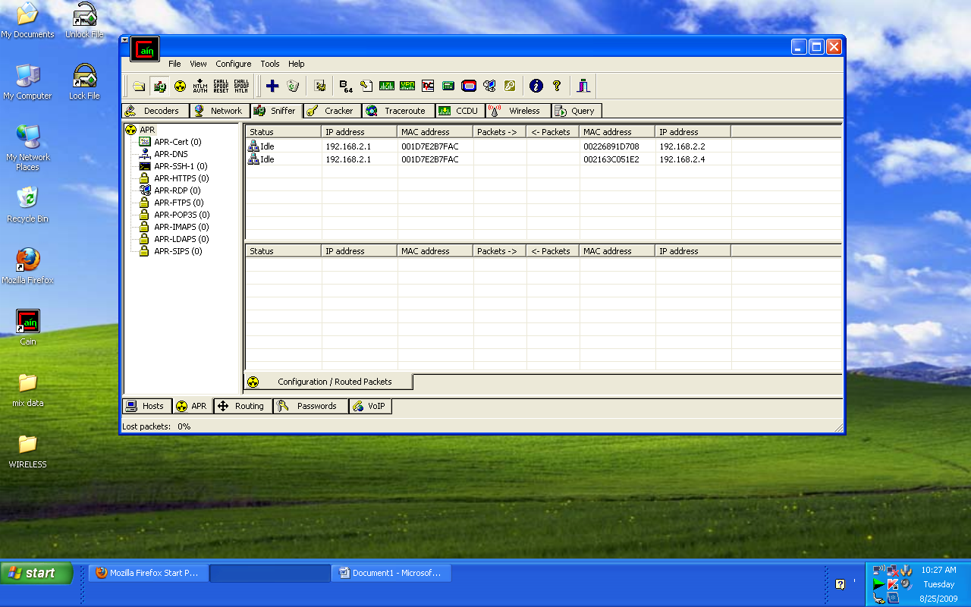

- Next, push the APR button to start sniffing. From the table below, it shows the status of sniffing process.
APR button
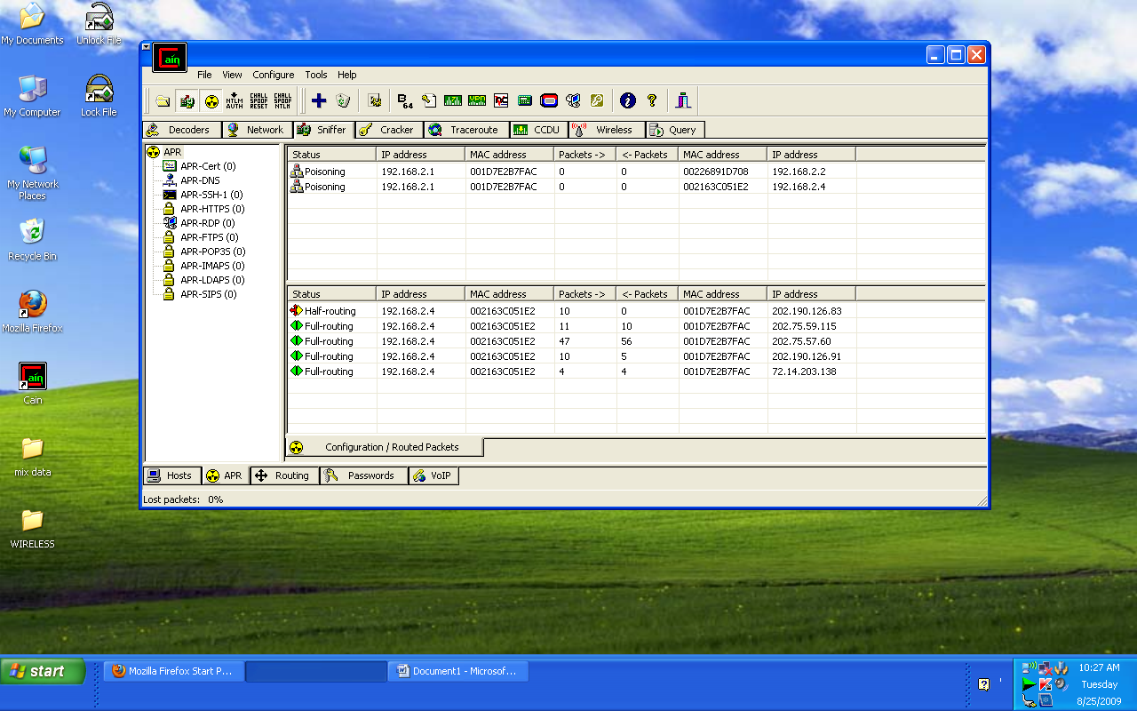

- -Click password toolbar. It will show you the ip address (victim) activities.
-You can see the username and password as below.
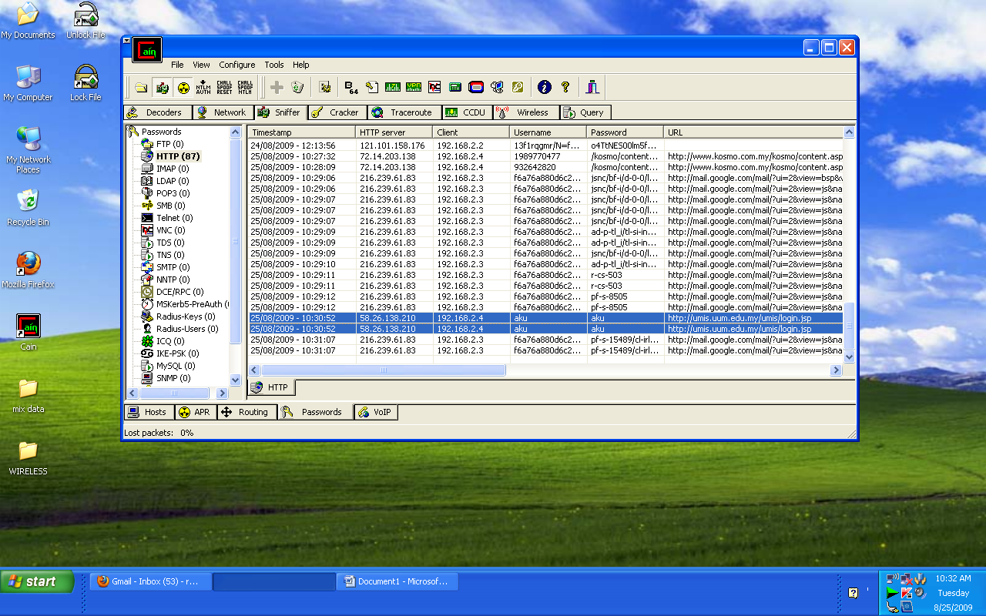
Password toolbar
username
password

- Finished.

